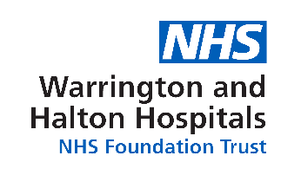
Configuring Microsoft Outlook after NHSMail2 Switchover
Staff Information
Once you have completed the initial registration of your new NHS Mail account, the next step is to configure Microsoft Outlook to use your new account for sending and receiving email. These instructions will guide you through this process.
Note: You will need to do this as a “one off” on every PC you use. Previously, you would set it up once and it would follow you around the network. This will no longer happen. If you use multiple machines as part of your role, it may be easier to use the web based system instead.
Before you follow these steps, you first need to complete the initial registration instructions.
Once that has been completed, you can return to these instructions.
(Note: The images are for Outlook 2010, but other than colour and design, all the fields and buttons are the same for Outlook 2013)
Open Microsoft Outlook. This will bring up the following Window…
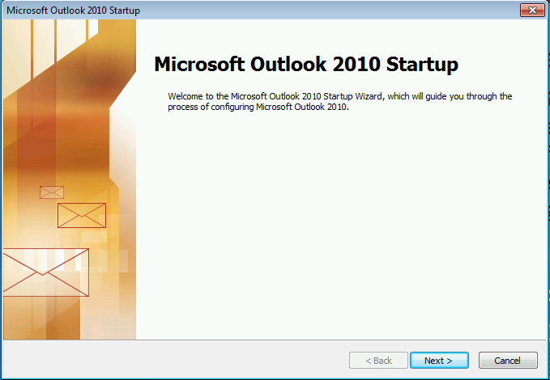
Click “Next >”
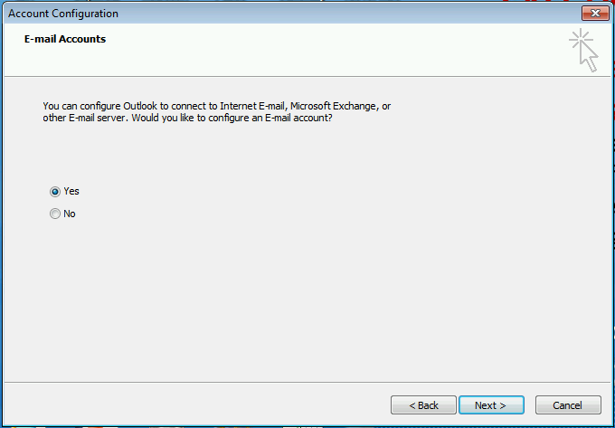
Click “Next >”

Enter your name, NHS email address and NHS mail password in the fields provided.
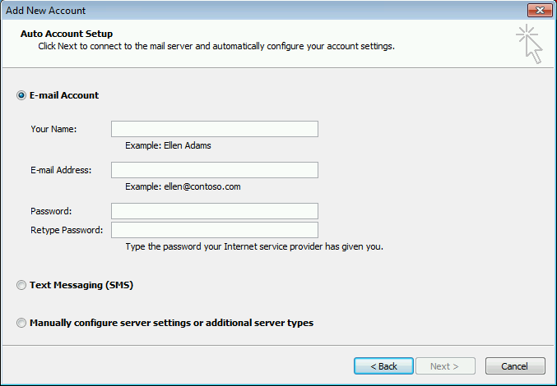
Outlook will now search for your account settings, this will take about 1 minute to complete.
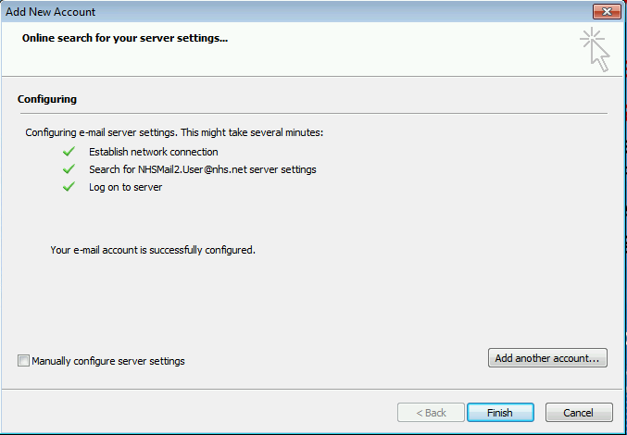
Once this has done, click “Finish”
Outlook will continue to load, but may make an additional request for your credentials.
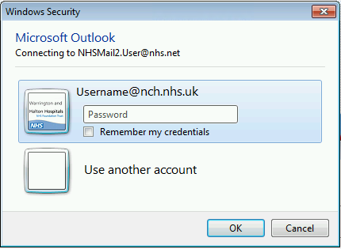
A known problem at this point, is that the dialog box is looking for an NCH account as the default, you will have to select the option for:
“Use Other Account”

Enter your full NHS email address as the user and then your NHS mail password and click “OK”
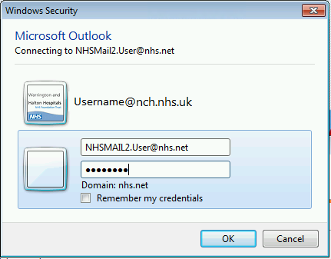
Outlook may then advise you that the program will need to be restarted. Please close outlook and then open it.
Once Outlook has launched again, it will again ask for your NHS mail password. Please note NHSmail2 does not recommend ticking the box to remember your credentials as this can cause accounts to get locked out.
You have now completed the set up for NHSmail 2 and can start using it.

