|  |  |  |  |  |  |  |  |
| --- | --- | --- | --- | --- | --- | --- | --- |
| **Med Car No:** |  | **Name of Driver on Duty:** | **Home Visit Record Log** | **Date of shift:**  **Start time:** |  | **Equipment bag Number:** |  |

|  |  |  |  |  |  |
| --- | --- | --- | --- | --- | --- |
| **Break Time start**  **Break Time Finish** |  | **Break Time start**  **Break Time Finish** |  | **Break Time start**  **Break Time Finish** |  |

|  |  |  |  |  |  |  |  |
| --- | --- | --- | --- | --- | --- | --- | --- |
| **No.** | **Call No.** | **Priority** | **T.O.A**  Time of Arrival | **T.O.D.D**  Time of Driver Departure | **Any Contact Made Y/N** | **Any other Comments –**  **Do not write any personal details of patients** | **Calling Card Left**  **NO PERSONAL INFO** |
| **1** |  |  |  |  |  |  |  |
| **2** |  |  |  |  |  |  |  |
| **3** |  |  |  |  |  |  |  |
| **4** |  |  |  |  |  |  |  |
| **5** |  |  |  |  |  |  |  |
| **6** |  |  |  |  |  |  |  |
| **7** |  |  |  |  |  |  |  |
| **8** |  |  |  |  |  |  |  |
| **9** |  |  |  |  |  |  |  |
| **10** |  |  |  |  |  |  |  |

**Urgent Care Coordinator: 0151 230 5554 / Shift Manager: 0151 221 5837 / Referral Coordinator: 0151 221 5835**

**Please do not write any personal details on this form, all identifiable information should be removed.**

|  |  |
| --- | --- |
| Date |  |
| Time of shift |  |
| Med Car No. |  |
| Hire Car Reg No. |  |

|  |  |  |  |  |  |  |
| --- | --- | --- | --- | --- | --- | --- |
| Check Item | Yes | No |  | Check Item | Yes | No |
| WATER | | |  | TYRES - OBSERVATIONS | | |
| Wipers |  |  |  | Tread (above 3mm) |  |  |
| Washers F/B |  |  |  | Pressure |  |  |
| LIGHTS | | |  | LOCKS | | |
| Brakes |  |  |  | Doors – inc boot |  |  |
| Indicators |  |  |  | Windows |  |  |
| Main/Side/Fog/Day/Real Licence Plate |  |  |  | CLEAN AND TIDY | | |
| Interior |  |  |  | Interior |  |  |
| Green Light |  |  |  | Exterior |  |  |
| Car Horn |  |  |  | Any damage – wear and tear |  |  |
| OIL | | |  | DASH |  |  |
| Oil – any Lights/Leaks |  |  |  | Warning lights |  |  |
| COMMENTS – HAVE YOU REPORTED TO THE SHIFT MANAGER? |  | | | | | |

|  |  |
| --- | --- |
| Fuel level |  |
| Fuel topped up? |  |

|  |  |  |  |
| --- | --- | --- | --- |
| IT EQUIPMENT | Yes | No | COMMENTS |
| Mobiles x 2 both working & charged? |  |  |  |
| In car charger working |  |  |  |
| Any Damage to laptop **START OF SHIFT**  Any damage to laptop **END OF SHIFT** |  |  |  |
| **ALL** Tamper stickers in place? |  |  |  |
| Please note any damage to the laptops using the diagram (to the right) and report to the Shift Manager asap. | | | |
| MEDS EQUIPMENT |  | | COMMENTS |
| Bags A&B tagged? |  |  |  |
| Resus bag tagged? |  |  |  |
| Have you got the defribilliator & nebuliser? |  |  |  |
| Prescriptions returned? |  |  |  |
| Winter pack in boot? |  |  |  |
| Please note any damage to the vehicle using the diagram (to the right) and report to the shift manager asap. | | | |

|  |  |  |
| --- | --- | --- |
|  |  | |
| **Print name** |  | |
| **Signature** |  | |
| **Checked by Fleet Lead** | **Signature** | **Date** |

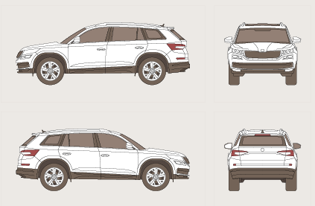

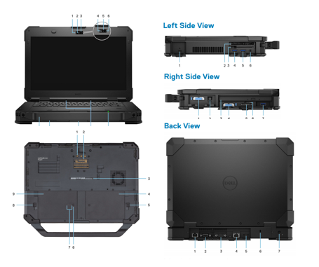

**Daily Car Check List**