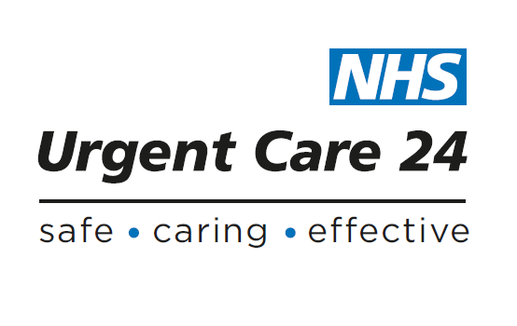

**Policy Checklist**

**Please use the checklist when developing a new policy or reviewing and existing policy.**

***Failure to ensure all processes and procedures have been followed could result in the delay of your policy implementation.***

|  |  |  |
| --- | --- | --- |
| **Insert name of Policy:** | **Yes / No** | **Date** |
| Policy Author identified |  |  |
| Policy incorporates the Corporate Design Cover |  |  |
| New Corporate Design Cover has been fully completed |  |  |
| The policy has been written in Arial 12 point |  |  |
| Format is justified |  |  |
| Spacing is 1.5 |  |  |
| Consistent use of headings and sub headings has been incorporated using bold |  |  |
| Components of policy are included as detailed in Policy for Policy Management Appendix 3. |  |  |
| Training needs identified and included in policy |  |  |
| Implementation plan completed and included in the policy |  |  |
| An Equality & Health Inequalities Screening has been completed. |  |  |
| Is a full Equality & Health Inequalities Analysis required |  |  |
| A full Equality & Health Inequalities Analysis has been completed if required. |  |  |
| A Privacy Impact Assessment has been completed |  |  |
| Policy has been presented at SMT |  |  |
| Policy has been presented to Policy Group for QA |  |  |
| Policy has been presented to Quality & Workforce Committee for assurance |  |  |
| Policy has been submitted to Board for Ratification |  |  |
| Following Ratification, Governance Team notified |  |  |
| Implementation Plan activated |  |  |
| Training plan in place |  |  |